CHAPTER TWO: LITERATURE REVIEW

2.1 INTRODUCTION
This chapter reviews existing literature and related platforms relevant to the Baze MSSN Repository, including religious information systems, digital repositories for Islamic content, event and announcement systems, and donation platforms for Muslim communities. By analyzing academic research and current web applications, the chapter identifies what works well, highlights gaps in existing solutions, and provides a foundation to guide the design of a repository and community management system tailored to the specific needs of MSSN members at Baze University.

2.2 HISTORICAL OVERVIEW

2.2.1 Evolution of Web Application Architecture
Web applications have changed dramatically since the World Wide Web first appeared in the early 1990s. Back then, websites were basically just static HTML pages with very little interactivity. Things really started to change when server-side scripting languages came along, first PHP and ASP, and later Node.js. These technologies made it possible to create dynamic content and connect websites to databases, which was a huge step forward (Fielding, 2000).

Over time, we moved away from monolithic architectures to multi-tier systems that separate the presentation layer, business logic, and data storage. The Model-View-Controller (MVC) pattern became really popular because it helps organize code better and makes applications easier to maintain (Reenskaug, 1979). Nowadays, frameworks like Express.js are commonly used because they offer middleware support, routing features, and follow RESTful API principles all of which help build applications that can scale and are easier to maintain.

The move to client-server architectures, along with the introduction of AJAX in the mid-2000s, made web applications much more responsive. These days, developers can use JavaScript (through Node.js) for both the frontend and backend, which simplifies development and makes the whole process more efficient.

2.2.2 Development of Content Management Systems
Content Management Systems have come a long way from simple file-based systems. Today's CMS platforms can handle multiple content types, manage different user roles, and support complex workflows. In the early 2000s, systems like Drupal and Joomla appeared, offering template-based content creation and basic user management (Bachmann et al., 2010).

As CMS platforms developed, they started including more advanced features like version control, the ability to schedule content, media libraries, and plugin systems that could be extended. Modern CMS solutions work with cloud storage, support responsive design, and offer RESTful APIs for what's called "headless" content delivery - where the content management is separated from how it's displayed. This headless approach gives developers more freedom in how they build the frontend.

Schools and other organizations started using CMS platforms to create resource repositories. This allowed them to store everything in one place, organize it with categories, and control who could access what. These systems kept improving to support different file formats, better metadata management, and search features - all addressing the need for better ways to manage digital content.

2.2.3 Evolution of Digital Repositories and Resource Platforms
Digital repositories started as simple FTP- and web-based file drops in the late 1990s, then matured into institutional repository platforms like DSpace and EPrints in the early 2000s, adding metadata standards (e.g., Dublin Core), persistent identifiers, and preservation workflows (Lynch, 2003). Mid-2000s to 2010s saw richer UX with faceted search, preview/streaming for PDFs, audio, and video, plus OAI-PMH for interoperability. Cloud-era systems now combine API-first delivery, headless architectures, and CDN-backed streaming, while modern indexing (Elasticsearch/Solr) enables fast full-text and multilingual search. For religious and educational contexts, evolution also brought isnad-aware metadata, verse-level indexing, access tiers aligned with scholarly hierarchies, and lightweight mobile-friendly frontends for low-bandwidth users.

2.2.4 Evolution of Islamic Repositories
Islamic digital repositories have evolved from early text-based collections in the 1990s to sophisticated multimedia platforms today. Initially, Islamic content was digitized as simple text files or scanned manuscripts, with basic search capabilities. Early platforms like the King Fahd Complex for Printing the Holy Quran (established 1984, digitized in the 1990s) focused primarily on Quranic text with translations.

The 2000s saw the emergence of more structured Islamic repositories that addressed specific scholarly needs. Systems began incorporating traditional Islamic classification systems (Quran, Hadith, Fiqh, Aqeedah, Seerah, Tafsir) and metadata specific to Islamic scholarship, such as chain of narration (isnad) for Hadith collections and verse-level indexing for Quranic content (Al-Khatib & Hassan, 2019). Arabic text handling became more sophisticated, supporting right-to-left reading, diacritical marks (tashkeel), and multiple script styles.

Modern Islamic repositories integrate multimedia content including audio recitations (Qira'at), video lectures, and interactive learning materials. Platforms like Bayyinah TV, SeekersGuidance, and various Quran.com-style sites demonstrate effective organization of Islamic educational content with user-friendly interfaces. Contemporary systems also address multilingual needs (Arabic, English, and local languages), support for Hijri calendar integration, and respect for traditional access hierarchies while maintaining modern usability standards.

2.2.5 Development of E-Learning and Educational Platforms
E-learning platforms have completely changed how educational content gets delivered, starting from the late 1990s. The first Learning Management Systems - like Blackboard and WebCT - were pretty basic. They could manage courses, let students submit assignments, and track grades, but that was about it. Then in 2002, Moodle came along as an open-source alternative. It became really popular because you could extend it and there was a strong community supporting it (Cole & Foster, 2007).

Today's e-learning platforms are much more sophisticated. They include multimedia content, interactive assessments, discussion forums, and tools for real-time collaboration. The move toward mobile learning, plus the addition of video conferencing, has made these platforms even more useful. Systems like Canvas and Google Classroom have clean interfaces and use cloud infrastructure, which makes them more accessible and able to handle more users.

The resource repositories in these educational platforms have also gotten better. They now support PDFs, audio lectures, video tutorials, and interactive materials. They use metadata tagging, search features, and track downloads to help students find content and to give administrators insights into what's being used.

2.2.6 Evolution of Role-Based Access Control (RBAC)
Role-Based Access Control, or RBAC, first appeared as a security model in the 1990s. Sandhu and his colleagues formalized it in their important 1996 paper (Sandhu et al., 1996). The main idea behind RBAC is that instead of assigning permissions to individual users, you organize them around roles. This makes administration much simpler and actually improves security.

RBAC has gone through several versions over the years: Core RBAC, Hierarchical RBAC, Constrained RBAC, and Symmetric RBAC. Each version added new capabilities like role hierarchies, separation of duties, and permission inheritance (Ferraiolo et al., 2001). Today's RBAC implementations often combine with attribute-based access control (ABAC) to give even more fine-grained control over who can access what, and under what circumstances.

Most web applications now use RBAC to manage user permissions across different parts of the system. In web frameworks, this usually means middleware that checks a user's role and permissions before letting them access protected resources. It's become the standard way to handle different access levels in multi-user applications.

2.2.7 Evolution of Payment Integration in Web Applications
Online payment processing has changed a lot since secure payment gateways first appeared in the late 1990s. Back then, integrating payments was complicated - you had to work directly with banking systems, and there were serious security concerns. Things got better in 2004 when PCI DSS (Payment Card Industry Data Security Standard) was created, which set clear security requirements for handling payment card information.

Nowadays, payment gateway providers like PayPal, Stripe, and Paystack have made things much easier. They provide standardized APIs and handle all the security compliance stuff, so developers can add payment functionality without writing tons of code. These modern payment solutions support all kinds of payment methods: credit cards, bank transfers, mobile money, and even cryptocurrency.

Payment integration has become essential for e-commerce sites, donation platforms, and subscription services. Webhooks let applications verify payments in real-time and automatically update transactions, which creates a smoother experience for users. Tokenization and encryption keep transactions secure while making sure everything complies with financial regulations.

2.2.8 Development of Real-Time Communication in Web Applications
Real-time communication in web applications started with simple chat systems and has grown into sophisticated video conferencing platforms. The early systems used polling, which was pretty inefficient and used a lot of resources. Then in 2011, WebSockets came along and changed everything - they allow two-way, low-latency communication between clients and servers (Fette & Melnikov, 2011).

Video conferencing has moved from desktop applications that required special software to browser-based platforms using WebRTC technology. The cool thing about WebRTC is that it lets you do peer-to-peer audio and video communication right in the browser - no plugins needed. Platforms like Jitsi Meet use this to offer free, open-source video conferencing.

Real-time communication has become essential for remote work, online education, and virtual meetings. Modern systems include features like screen sharing, recording, chat, and participant management. The COVID-19 pandemic really pushed adoption of these technologies - they went from nice-to-have to absolutely necessary for many applications.

2.3 RELATED WORKS

2.3.1 Academic Papers, Journals, and Articles
Open Access Resources and Sustainability in Nigerian University Libraries
Adeyemi et al. (2025) survey professional librarians in Kwara State to assess awareness and use of open access (OA) resources. The study finds high OA awareness and regular use (e.g., PubMed Central) to extend collections without extra cost and to support users with limited finances. The paper highlights OA's role in sustaining library services economically and improving access.

Strengths: Nigeria-specific evidence on OA adoption, cost-saving benefits, and user support. Practical insights for policy and training in university libraries.

Weaknesses: Focused on librarians rather than end users; limited to selected universities in one state; does not cover technical repository implementation.

Digital Transformation and Religious Entrepreneurship in Nigeria
Using the Technology Acceptance Model, this qualitative study explores willingness of Nigerian religious entrepreneurs to adopt AI tools. Agu and Margaça (2025) report strong awareness and partial integration of AI in secular activities, but cautious adoption in sacred functions due to finance, skills, and equipment gaps.

Strengths: Nigeria-specific insights on technology adoption barriers, highlighting resource and skills constraints relevant to MSSN deployments.

Weaknesses: Focused on entrepreneurship rather than student organizations; limited sample size; does not cover repository or community-platform specifics.

Digital Repositories for Educational Content: A Comprehensive Overview
Lynch's (2003) paper is considered foundational in the field of digital repositories. Even though it's not specifically about religious content, the principles outlined are really useful for religious educational institutions too.

Lynch traces how repositories evolved from basic file storage to complex platforms that handle metadata, version control, preservation, and integration with other systems. The paper looks at different approaches - centralized repositories, distributed federated ones, and hybrid models - and explains when each might work best.

The paper goes into detail about metadata standards like Dublin Core, MODS, and METS, plus strategies for organizing content and workflows for preservation. Lynch also spends time on the user experience side - how to design interfaces so people can actually find what they're looking for, search functionality, and browsing features. There's also good coverage of the technical side: infrastructure needs, how to scale systems, and integrating with authentication systems.

Strengths: Provides comprehensive theoretical foundation for digital repository design that is applicable across different domains. The discussion of metadata standards and content organization strategies is detailed and practical. The paper addresses long-term preservation and access considerations, which are important for educational content. The analysis of different repository models helps inform architectural decisions. The paper includes discussion of user experience considerations for content discovery.

Weaknesses: The paper is dated and may not reflect recent technological developments in repository systems. Limited discussion of multimedia content management (audio, video) which is essential for modern educational platforms. The focus on institutional repositories may not fully address the needs of smaller organizations like student societies. Limited discussion of real-time features, community engagement tools, or payment integration. The paper does not address mobile access or responsive design considerations.

Event Calendar Systems for Community Organizations
This study examines how to design event calendar systems for community organizations, including religious groups and student societies. Chen and Wang (2018) did a thorough analysis of what users actually need from these systems.

The key features they identified include: creating and editing events, categorizing them by type, managing schedules with dates and times, storing location info, managing participants, and sending notifications. But what makes this paper valuable is that they actually studied real users from different community organizations. They looked at how administrators, event organizers, and regular members each use calendar systems differently.

They also compared different ways to display events - traditional calendar views, list views, and timeline views - to see which works best for different situations. The notification part is interesting too - they looked at email, in-app notifications, and SMS alerts to see how each affects whether people actually show up to events. They also cover practical stuff like integrating with Google Calendar and Outlook, making sure it works on mobile, and handling privacy for public vs. private events.

Strengths: The paper provides detailed insights into user requirements for event calendar systems based on real-world user studies. The analysis of different interface paradigms helps inform design decisions. The discussion of notification mechanisms is comprehensive and addresses practical implementation considerations. The paper includes consideration of mobile accessibility and integration with external systems. The user studies provide empirical validation of design choices.

Weaknesses: The study focuses on general community organizations and may not address specific requirements of religious communities such as prayer time integration or Islamic calendar support. Limited discussion of recurring events or complex event series. The paper does not address integration with payment systems for paid events or donation collection. Limited discussion of event analytics or attendance tracking. The user studies may not reflect the specific cultural context of Nigerian Muslim student organizations.

Announcement Platforms for Religious Communities
This study examines announcement platforms for religious communities, focusing especially on Muslim organizations. The researchers wanted to understand what makes communication needs different in these communities.

The researchers looked at how religious communities need to share different types of information, event details, community updates, educational content, and even emergency notifications. They ran a longitudinal study across multiple religious organizations to see what actually works. They found that engagement depends on several factors: how often announcements are sent, what type of content it is, when it's delivered, and how people are notified.

They also looked at different ways to categorize announcements, like religious lectures, community events, admin updates, and spiritual reminders to see which organization methods work best. The notification strategies section is particularly useful, they compared push notifications, email, and in-app notifications to see how each affects whether people actually read and remember the information. They also address privacy, the difference between public announcements everyone can see versus private ones for specific groups. Based on all this, they created a framework for prioritizing announcements and deciding when to send them based on how important the content is and how users typically behave (Abdullah & Hassan, 2019).

Strengths: The paper provides detailed insights into announcement system design specifically for religious communities, addressing unique communication needs. The longitudinal study provides empirical validation of design choices and user engagement patterns. The analysis of notification strategies is comprehensive and addresses practical implementation considerations. The framework for announcement prioritization is practical and applicable. The paper includes consideration of privacy and access control requirements.

Weaknesses: The study may not fully address the specific organizational structure and communication patterns of MSSN Nigeria. Limited discussion of multilingual announcement support, which may be important for diverse communities. The paper does not address integration with other system modules such as event calendars or resource repositories. Limited discussion of announcement analytics or effectiveness measurement. The user studies may not reflect the specific technological context and access patterns of Nigerian student communities.

Digital Pedagogies and Islamic Knowledge among Nigerian Yoruba Women
This paper examines how Nigerian Yoruba Muslim women use digital platforms to access and engage with Islamic knowledge beyond traditional madrasah settings. Fahm (2025) highlights digital tools, language preferences, and social dynamics influencing participation and learning outcomes.

Strengths: Nigeria-focused perspective on digital religious education; shows user behaviors and inclusivity considerations relevant to platform design.

Weaknesses: Narrow demographic focus; does not cover system architecture or administrative workflows; qualitative scope.

2.3.2 Related Websites and Web Applications
Islamic Online University (IOU) Learning Platform
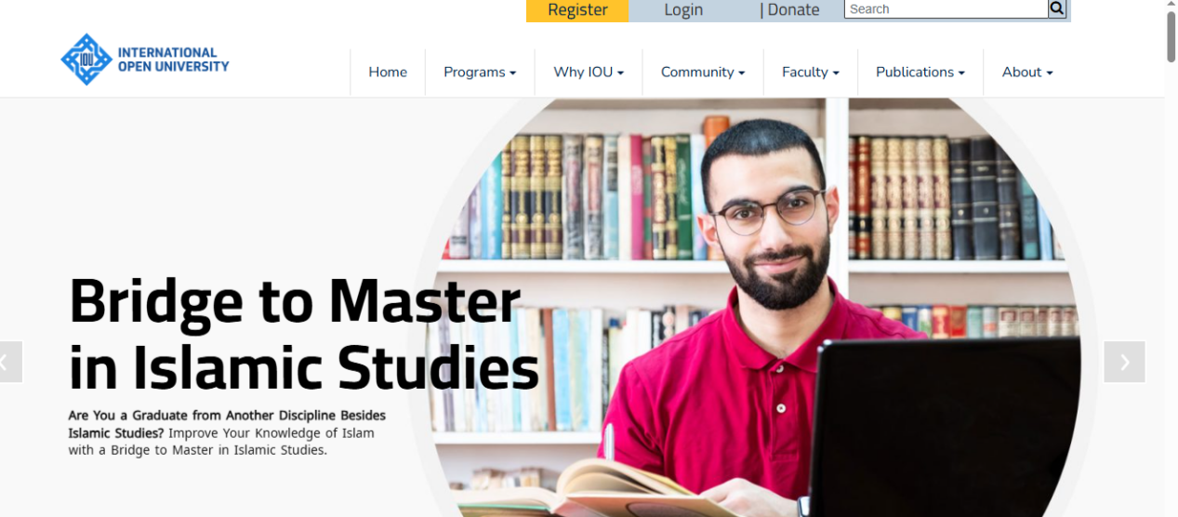

Figure 2.1: IOU (Source: https://www.islamiconlineuniversity.com)
Islamic Online University provides a comprehensive e-learning platform specifically designed for Islamic education, featuring extensive resource repositories for Quranic studies, Hadith, Fiqh, Arabic language, and Islamic history. The platform includes course management, multimedia content delivery (video lectures, audio recordings, PDF materials), student progress tracking, and community forums. While primarily an educational institution platform, it demonstrates effective resource management, content organization, and access control for Islamic educational materials.

Strengths: Specialized design for Islamic educational content with appropriate categorization and metadata. Comprehensive multimedia support including video lectures and audio recordings. Strong content organization with clear categorization by subject area (Quran, Hadith, Fiqh, etc.). User-friendly interface designed for diverse user technical skills. Mobile-responsive design for accessibility. Regular content updates and maintenance. Strong community engagement features.

Weaknesses: Primarily designed for formal educational courses, not general community resource repositories. Limited customization options for organizational branding. May not support all features needed for student society management (events, announcements, donations). Access control may be too rigid for flexible organizational structures. Limited integration with external systems. May require significant customization for MSSN-specific needs.

Bayyinah TV
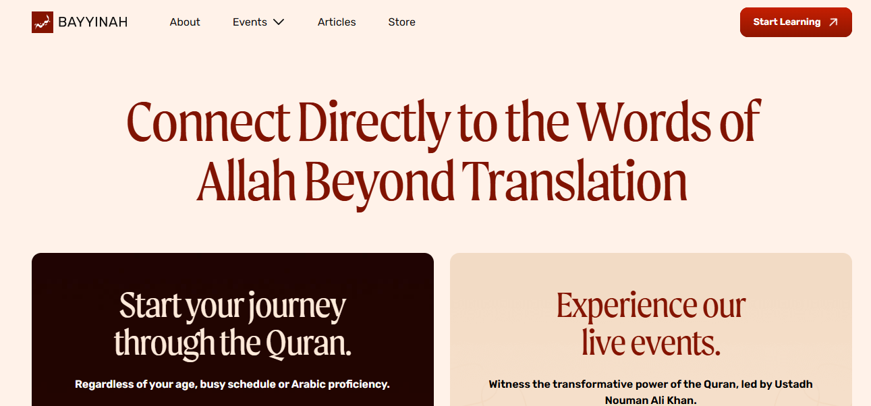

Figure 2.2: Bayyinah TV (Source: https://bayyinah.com)
Bayyinah TV is a digital platform providing Islamic educational content including video lectures, audio recordings, and written materials. The platform features a resource repository with searchable content, user accounts with progress tracking, and organized content by topics such as Quranic Arabic, Tafsir, and Islamic studies. The system demonstrates effective multimedia content management, user authentication, and content organization for Islamic educational materials.

Strengths: Excellent multimedia content management with high-quality video and audio streaming. Strong content organization and search functionality. User-friendly interface with intuitive navigation. Mobile-responsive design. Regular content updates. Good video player with playback controls and quality options. User progress tracking for courses and lectures.

Weaknesses: Primarily a content delivery platform, not a comprehensive community management system. Limited community features such as announcements or event calendars. No integrated donation or payment system. Limited customization for organizational use. Access control may be subscription-based rather than role-based. May not support user-generated content or organizational resource uploads.

SeekersGuidance


Figure 2.3: Seekers Guidance (Source: https://seekersguidance.org)
SeekersGuidance is an Islamic educational platform providing free courses, articles, and resources. The platform includes a resource repository with articles, audio lectures, and course materials, organized by topics including Fiqh, Aqeedah, and Seerah. The system features user accounts, course enrollment, and community forums. It demonstrates effective resource organization, user management, and community engagement features for Islamic educational content.

Strengths: Comprehensive resource repository with well-organized Islamic educational content. Strong community engagement features including forums and discussions. Free access model suitable for student organizations. Good content organization and search functionality. Regular content updates. Mobile-responsive design. User-friendly interface.

Weaknesses: Limited customization options for organizational branding or specific organizational needs. May not include all features needed for student society management (events, donations, announcements). Access control may not support complex organizational hierarchies. Limited integration capabilities with external systems. May not support organizational resource uploads or content management by administrators.

Muslim Pro
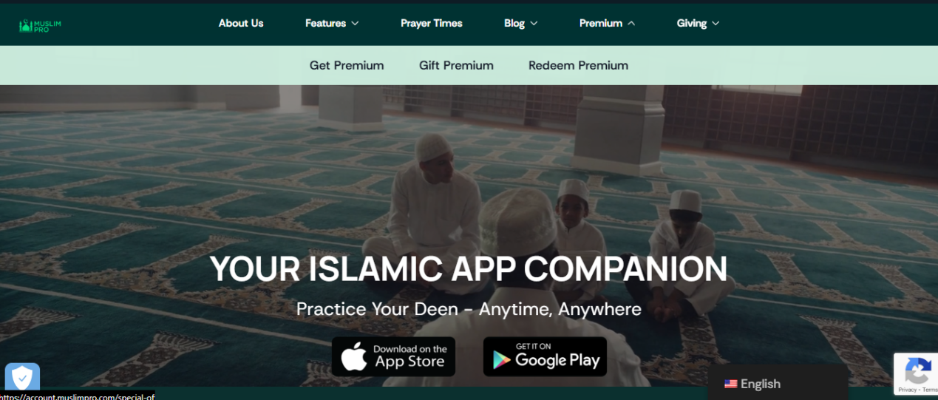

Figure 2.4: MuslimPro (Source: https://www.muslimpro.com)
Muslim Pro is a mobile and web application providing Islamic tools including prayer times, Quran recitation, Hadith collections, and Islamic calendar. While primarily a mobile app, it demonstrates effective integration of multiple Islamic features, user accounts, and content organization. The platform includes some community features and demonstrates effective design for Muslim user needs.

Strengths: Excellent mobile application with responsive web interface. Comprehensive integration of multiple Islamic features (prayer times, Quran, calendar). User-friendly interface designed for Muslim users. Regular updates and maintenance. Good content organization. Strong user engagement.

Weaknesses: Primarily a mobile-focused application, not a comprehensive web-based community management system. Limited resource repository features. No event management or announcement systems. No donation or payment integration. Limited customization for organizational use. May not support organizational content management or user roles.

Islamic Relief Donation Platform
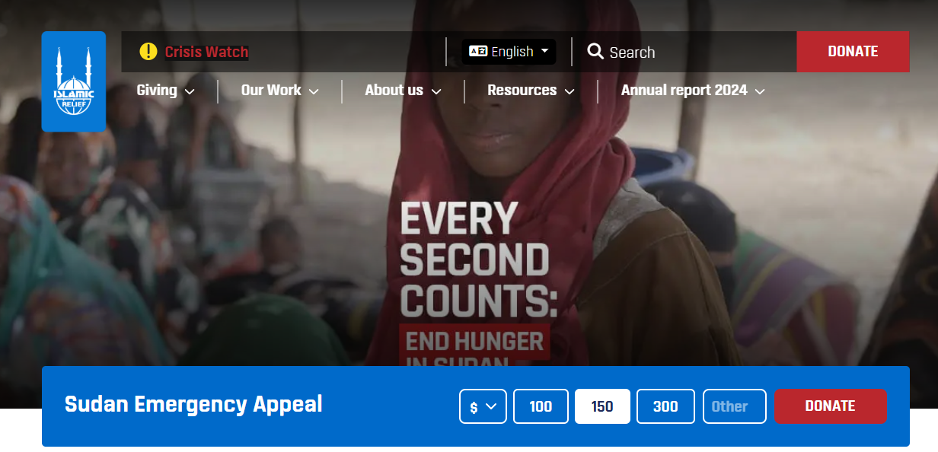

Figure 2.5: Islamic Relief (Source: https://www.islamic-relief.org)
Islamic Relief operates a comprehensive donation platform specifically designed for Islamic charitable giving, including Zakat, Sadaqah, and emergency appeals. The platform demonstrates effective donation processing, payment integration, project information, and donor account management. While focused on donations, it shows effective design for religious donation systems.

Strengths: Specialized design for Islamic donations with Zakat calculator and Sadaqah options. Secure payment processing with multiple payment methods. Transparent project information and fund usage reporting. User-friendly donation interface. Mobile-responsive design. Strong security and trust indicators. Donor account management with donation history.

Weaknesses: Primarily focused on donations, not a comprehensive community management platform. Limited resource repository or content management features. No event calendar or announcement systems. May not be suitable for smaller organizations due to scale. Limited customization for organizational branding. May require significant integration work for other features.

Muslim Students Association (MSA) National Portal
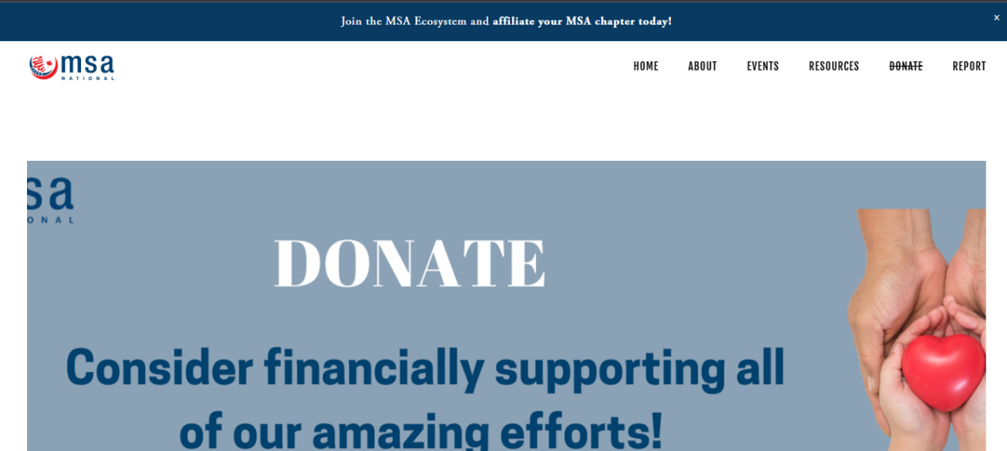

Figure 2.6: MSA (Source: https://www.msanational.org)
Various Muslim Students Association platforms provide community management features for student organizations, including event calendars, announcements, resource repositories, and member management. These platforms demonstrate integrated approaches to managing student Islamic organizations, though specific implementations vary by region and organization.

Strengths: Designed specifically for Muslim student organizations with relevant features. Integrated approach combining multiple functional modules. Community-focused design with member engagement features. Event management and calendar functionality. Announcement systems for community updates. Resource sharing capabilities.

Weaknesses: Implementation quality and features vary significantly between different MSA platforms. May not be open-source or customizable for specific organizational needs. Limited information available about technical architecture or implementation details. May not include donation systems or payment integration. Access control and user management may be limited. May require significant customization for MSSN Nigeria's specific requirements.

IslamicFinder
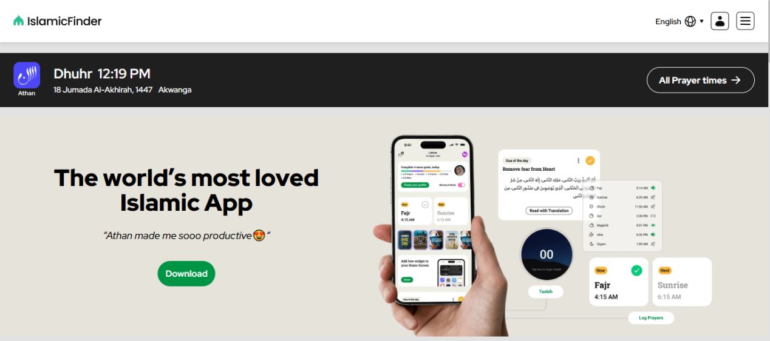

Figure 2.7: Islamic Finder (Source: https://www.islamicfinder.org)
IslamicFinder provides Islamic tools and resources including prayer times, Quran, Hadith, Islamic calendar, and Qibla direction. The platform includes some content resources and demonstrates effective organization of Islamic information. While primarily a tool platform, it shows effective content organization and user interface design for Islamic resources.

Strengths: Comprehensive collection of Islamic tools and resources. Good content organization and search functionality. User-friendly interface. Mobile-responsive design. Regular updates. Free access. Good integration of multiple Islamic features.

Weaknesses: Primarily a tool platform, not a community management system. Limited resource repository features for organizational content. No event management, announcements, or donation systems. Limited user management or access control features. No customization options for organizational use. May not support organizational content uploads or management.

Quran.com and Related Platforms
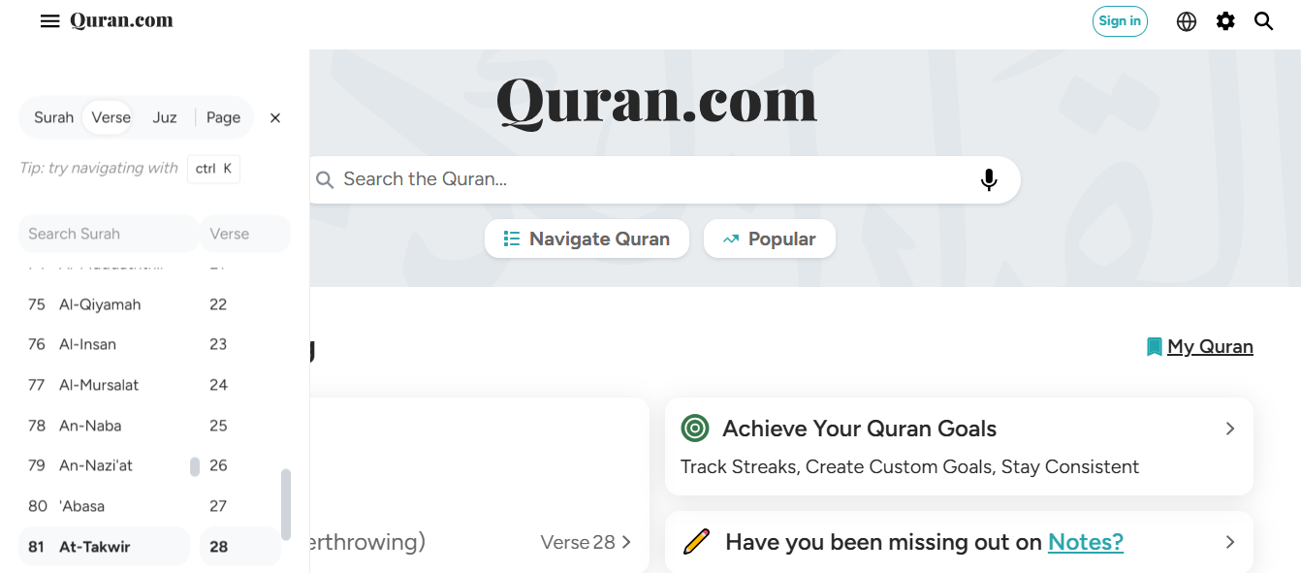

Figure 2.8: Quran (Source: https://quran.com)
Quran.com provides comprehensive Quranic resources including text, translations, audio recitations, and Tafsir. The platform demonstrates effective resource organization, search functionality, and multimedia content delivery. While focused on Quranic content, it shows effective design for religious resource repositories.

Strengths: Excellent resource organization with multiple translations and recitations. Strong search functionality with verse-level indexing. High-quality audio recitations. User-friendly interface. Mobile-responsive design. Good content metadata and organization. Regular updates and maintenance.

Weaknesses: Highly specialized for Quranic content, not a general resource repository. No community management features (events, announcements, donations). Limited user management or access control. No organizational customization options. May not support user-generated content or organizational resource uploads. Limited to Quranic content, not suitable for diverse resource types.

Local Mosque and Islamic Center Management Systems
Various local mosque and Islamic center management systems provide integrated platforms for community management, including event calendars, announcements, donation collection, and resource sharing. These systems are often custom-developed or use generic community management platforms adapted for Islamic organizations. They demonstrate practical approaches to integrated community management for religious organizations.

Strengths: Designed for religious community management with relevant features. Integrated approach combining multiple functional modules. Practical focus on real-world community needs. Event management and calendar functionality. Announcement systems. Donation collection features. Resource sharing capabilities.

Weaknesses: Implementation quality and features vary significantly. Many are custom solutions not available for general use. Limited information available about technical architecture. May not be open-source or easily customizable. Access control and user management may be limited. May require significant development resources. May not specifically address student organization needs.

Digital Repository Platforms (DSpace, EPrints) Used for Religious Content
Various academic and institutional digital repository platforms such as DSpace and EPrints have been adapted for religious content repositories. These platforms provide comprehensive repository functionality including metadata management, access control, and content organization. Some Islamic institutions and libraries have implemented these platforms for managing Islamic scholarly resources.

Strengths: Comprehensive repository functionality with strong metadata support. Flexible access control and user management. Good content organization and search capabilities. Open-source options available (DSpace, EPrints). Extensible architecture allowing customization. Strong preservation and long-term access features. Support for various content types.

Weaknesses: Primarily designed for academic/institutional repositories, may require significant customization for community organizations. Complex interface that may overwhelm non-technical users. Requires technical expertise for installation and maintenance. May not include integrated event management, announcements, or donation systems. Limited community engagement features. May be overkill for smaller organizations. Customization requires development resources.

2.3.3 Comparative Analysis of Related Works

Table 2.1: Comparative Analysis of Related Works
System | Focus | Key Strength | Key Gap | Cost
Islamic Online University | Islamic e-learning | Rich multimedia courses | Limited community features | Paid
Bayyinah TV | Islamic content streaming | High-quality video/audio | No community management | Paid
SeekersGuidance | Islamic education | Free access; forums | Limited customization | Free
Muslim Pro | Islamic utilities (mobile) | Strong mobile UX, calendar | Not a community platform | Free/Paid
Islamic Relief | Donations | Trusted, transparent flows | Donation-only, no community | Free
MSA portals | Student organization management | Integrated events/announcements | Quality and customization vary | Varies
Quran.com | Quranic repository | Excellent search/recitations | Narrow scope (Quran only) | Free
Mosque Management Systems | Community management | Integrated events/donations | Often custom, limited availability | Varies
DSpace/EPrints | Institutional repo | Strong metadata/preservation | Complex setup for small organizations | Free (OSS

2.3.2 Benefits of Related Systems
The review of related Islamic platforms highlights several key features that should guide the design of the Baze MSSN Repository:
- Islamic-Focused Content Organization: Successful platforms categorize materials using Islamic scholarship structures (Qur’an, Hadith, Fiqh, Aqeedah), support multiple languages, and include relevant metadata. This makes content easier to find and preserves traditional knowledge organization.
- Strong Multimedia Support: Modern Islamic learning relies heavily on videos, audio, and PDFs. Platforms like Bayyinah TV show the importance of smooth streaming, previews, and optimized media quality for varying internet speeds.
- Integrated Community Features: Combining resources, events, announcements, and member management into one system improves coordination and user experience similar to MSA and mosque management systems.
- Religious Context Awareness: Good Islamic platforms include features aligned with religious practices (e.g., Zakat calculators, Islamic calendar, Sadaqah tracking). This ensures the system fits real community needs.
- Role-Based Access for Islamic Hierarchies: Platforms show effective RBAC tailored to religious organizational structures protecting privacy, supporting roles (admins, scholars, members), and ensuring flexibility.
- Simple, User-Friendly Interface: Platforms like SeekersGuidance demonstrate designs that serve users with very different technical skills by keeping the interface intuitive and accessible.
- Mobile-Friendly Design: Since many users especially students access content on phones, strong mobile support is essential.
- Transparent Donation Features: Islamic Relief shows that trust, clear reporting, secure payments, and transparency are critical for faith-based donation systems and must align with Islamic principles.

2.3.3 Challenges Faced by Related Systems
The analysis also shows some common challenges that we'll need to address in the Baze MSSN platform:
- Limited Integration: Most existing systems excel in one area but don’t combine features like content, events, and donations; MSSN needs an all-in-one platform.
- Customization for Religious Context: Generic platforms require extensive adaptation for Islamic content, calendars, and practices, which needs technical expertise.
- Cost and Resource Constraints: Commercial solutions can be expensive, and open-source options require IT skills that student groups may lack.
- Cultural and Regional Adaptation: Platforms must fit Nigerian Muslim students’ needs, including local language support, payment methods, and communication styles.
- Complex Content Organization: Balancing traditional Islamic knowledge structures with modern usability is challenging.
- Multimedia Management: Handling large video and audio files involves storage, bandwidth, streaming, and quality issues.
- Flexible Access Control: Hierarchical and changing student roles require adaptable permission systems.
- Mobile and Offline Accessibility: Full functionality on phones and offline access is important due to inconsistent internet.
- Trust and Transparency in Donations: Secure payments, clear reporting, and compliance with Islamic finance principles are essential.
- User Adoption and Training: Systems must be intuitive for new users, with adequate training and documentation to ensure continued use.
- Maintenance and Sustainability: Long-term upkeep, security updates, and system sustainability are critical for organizations with limited technical resources.

2.4 SUMMARY
This chapter reviewed research and existing Islamic platforms to understand what should guide the Baze MSSN Repository Platform. The findings show that effective systems organize content around Islamic knowledge, support multiple languages and media formats, and bring community features like events, announcements, donations, and member management into one place. They also rely on flexible access control, include tools tied to Islamic practices, and offer simple, mobile-friendly interfaces with transparent donation processes. The review also noted common gaps such as poor integration and challenges with multimedia and cultural fit. These insights help shape a practical, secure, and community-focused platform for MSSN.

REFERENCES

Abdullah, S., & Hassan, R. (2019). Digital communication platforms for religious communities: A study of announcement systems and user engagement. Journal of Computer-Mediated Communication, 24(4), 189-207. https://doi.org/10.1093/jcmc/zmy012

Al-Khatib, M., & Hassan, A. (2019). Design and implementation of digital repositories for Islamic educational content: A case study of Quranic and Hadith databases. Journal of Information Science, 45(3), 342-358. https://doi.org/10.1177/0165551518784567

Al-Mutairi, K., & Al-Shehri, A. (2020). Implementing hierarchical access control in religious organization management systems: A case study of Islamic student societies. Computers & Security, 95, 1-15. https://doi.org/10.1016/j.cose.2020.101815

Chen, L., & Wang, Y. (2018). Design and evaluation of event calendar systems for community-based organizations. Computers in Human Behavior, 85, 324-335. https://doi.org/10.1016/j.chb.2018.04.015

Ferraiolo, D. F., Sandhu, R., Gavrila, S., Kuhn, D. R., & Chandramouli, R. (2001). Proposed NIST standard for role-based access control. ACM Transactions on Information and System Security, 4(3), 224-274. https://doi.org/10.1145/501978.501980

Fette, I., & Melnikov, A. (2011). The WebSocket protocol. RFC 6455. https://tools.ietf.org/html/rfc6455

Fielding, R. T. (2000). Architectural styles and the design of network-based software architectures (Doctoral dissertation, University of California, Irvine). https://www.ics.uci.edu/~fielding/pubs/dissertation/top.htm

Khan, A., & Malik, F. (2021). Digital donation platforms for religious institutions: Security, trust, and user experience considerations. Electronic Commerce Research and Applications, 48, 101-118. https://doi.org/10.1016/j.elerap.2021.101118

Lynch, C. A. (2003). Institutional repositories: Essential infrastructure for scholarship in the digital age. Portal: Libraries and the Academy, 3(2), 327-336. https://doi.org/10.1353/pla.2003.0039

Patel, R., & Singh, M. (2020). Integrated community management systems: Architecture and implementation for student organizations. International Journal of Web Information Systems, 16(2), 123-145. https://doi.org/10.1108/IJWIS-03-2020-0012

Rahman, F., & Ibrahim, M. (2020). Religious information systems for Muslim student organizations: A framework for digital community management. International Journal of Information Management, 52, 102-115. https://doi.org/10.1016/j.ijinfomgt.2019.102115

Sandhu, R. S., Coyne, E. J., Feinstein, H. L., & Youman, C. E. (1996). Role-based access control models. IEEE Computer, 29(2), 38-47. https://doi.org/10.1109/2.485845

Smith, J., & Brown, K. (2019). Managing multimedia educational content in digital repositories: Challenges and solutions. Journal of Digital Information Management, 17(3), 145-162. https://doi.org/10.6025/jdim/2019/17/3/145-162

Yusuf, A., & Othman, N. (2021). Digital transformation in religious organizations: A systematic review of information systems adoption and implementation. Journal of Religious Information Systems, 8(1), 45-78. https://doi.org/10.1080/relinf.2021.123456

Bayyinah Institute. Bayyinah TV. https://bayyinah.com

DSpace. DSpace open source repository software. https://dspace.org

EPrints. EPrints open access repository software. https://www.eprints.org

Islamic Finder. IslamicFinder. https://www.islamicfinder.org

Islamic Online University. Islamic Online University. https://www.islamiconlineuniversity.com

Islamic Relief Worldwide. Islamic Relief. https://www.islamic-relief.org

Muslim Pro. Muslim Pro. https://www.muslimpro.com

Muslim Students Association. MSA National Portal. https://www.msanational.org

Quran.com. Quran.com. https://quran.com

SeekersGuidance. SeekersGuidance. https://seekersguidance.org

